**Table of Contents**

Startup Screen 1

Project Properties 2

Project (BPR Links) 3

Node-Link Data 4

Specify Node-Link Data 5

Example Horseshoe Network 6

Node Numbering 7

Origin-Destination Data 8

Specify Origin-Destination Data 9

Run Analysis 10

Results 11

Project (Freeway Facilities) 12

Node-Link Data 13

Specify Node-Link Data 14

Example Network 15

Node-Link Data 16

Freeway Facilities 17

Travel Time-Flow Relationship 18

Origin-Destination Data 19

Specify Origin-Destination Data 20

Run Analysis 21

Results 22

# Startup Screen

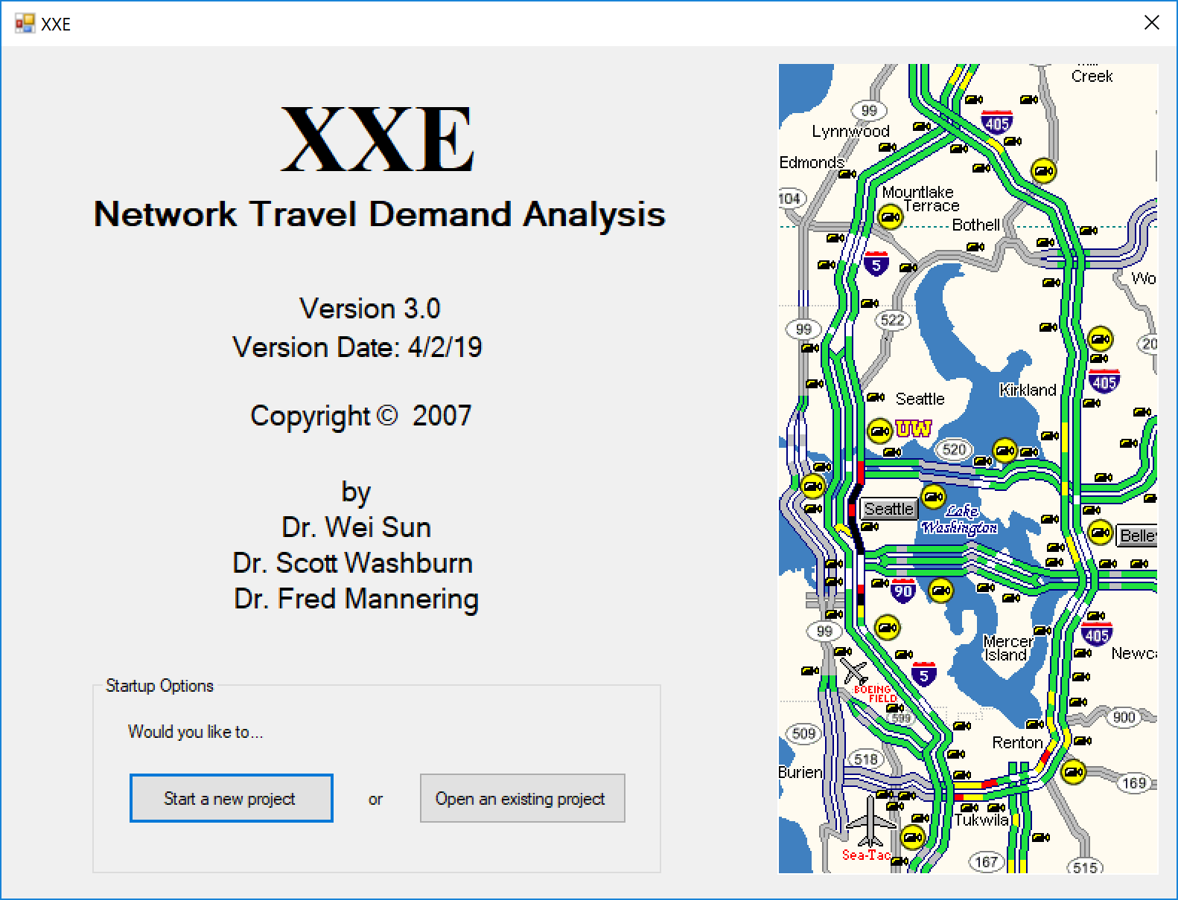

Select ‘Start a new project’ or ‘Open an existing project’.

# Project Properties

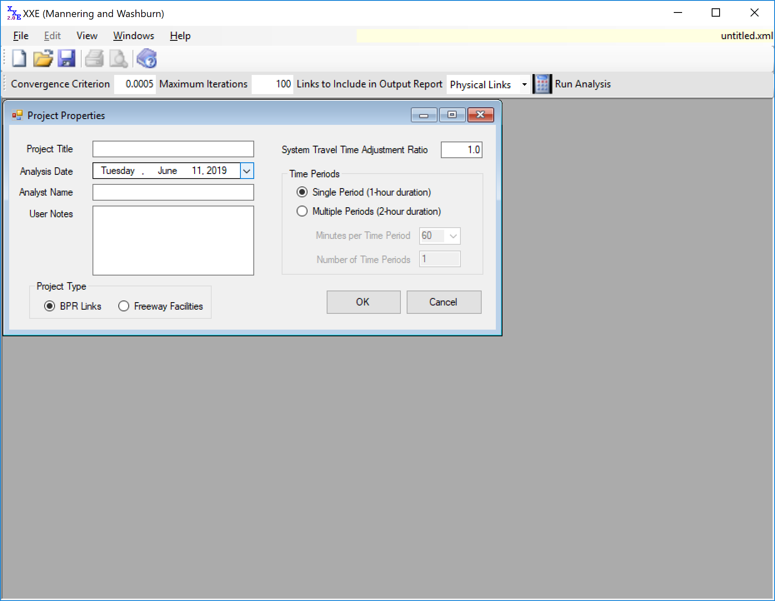

Fill in the project description and analyst information. Select single period or multiple periods. Select project type.

# Project (BPR Links)

## Node-Link Data

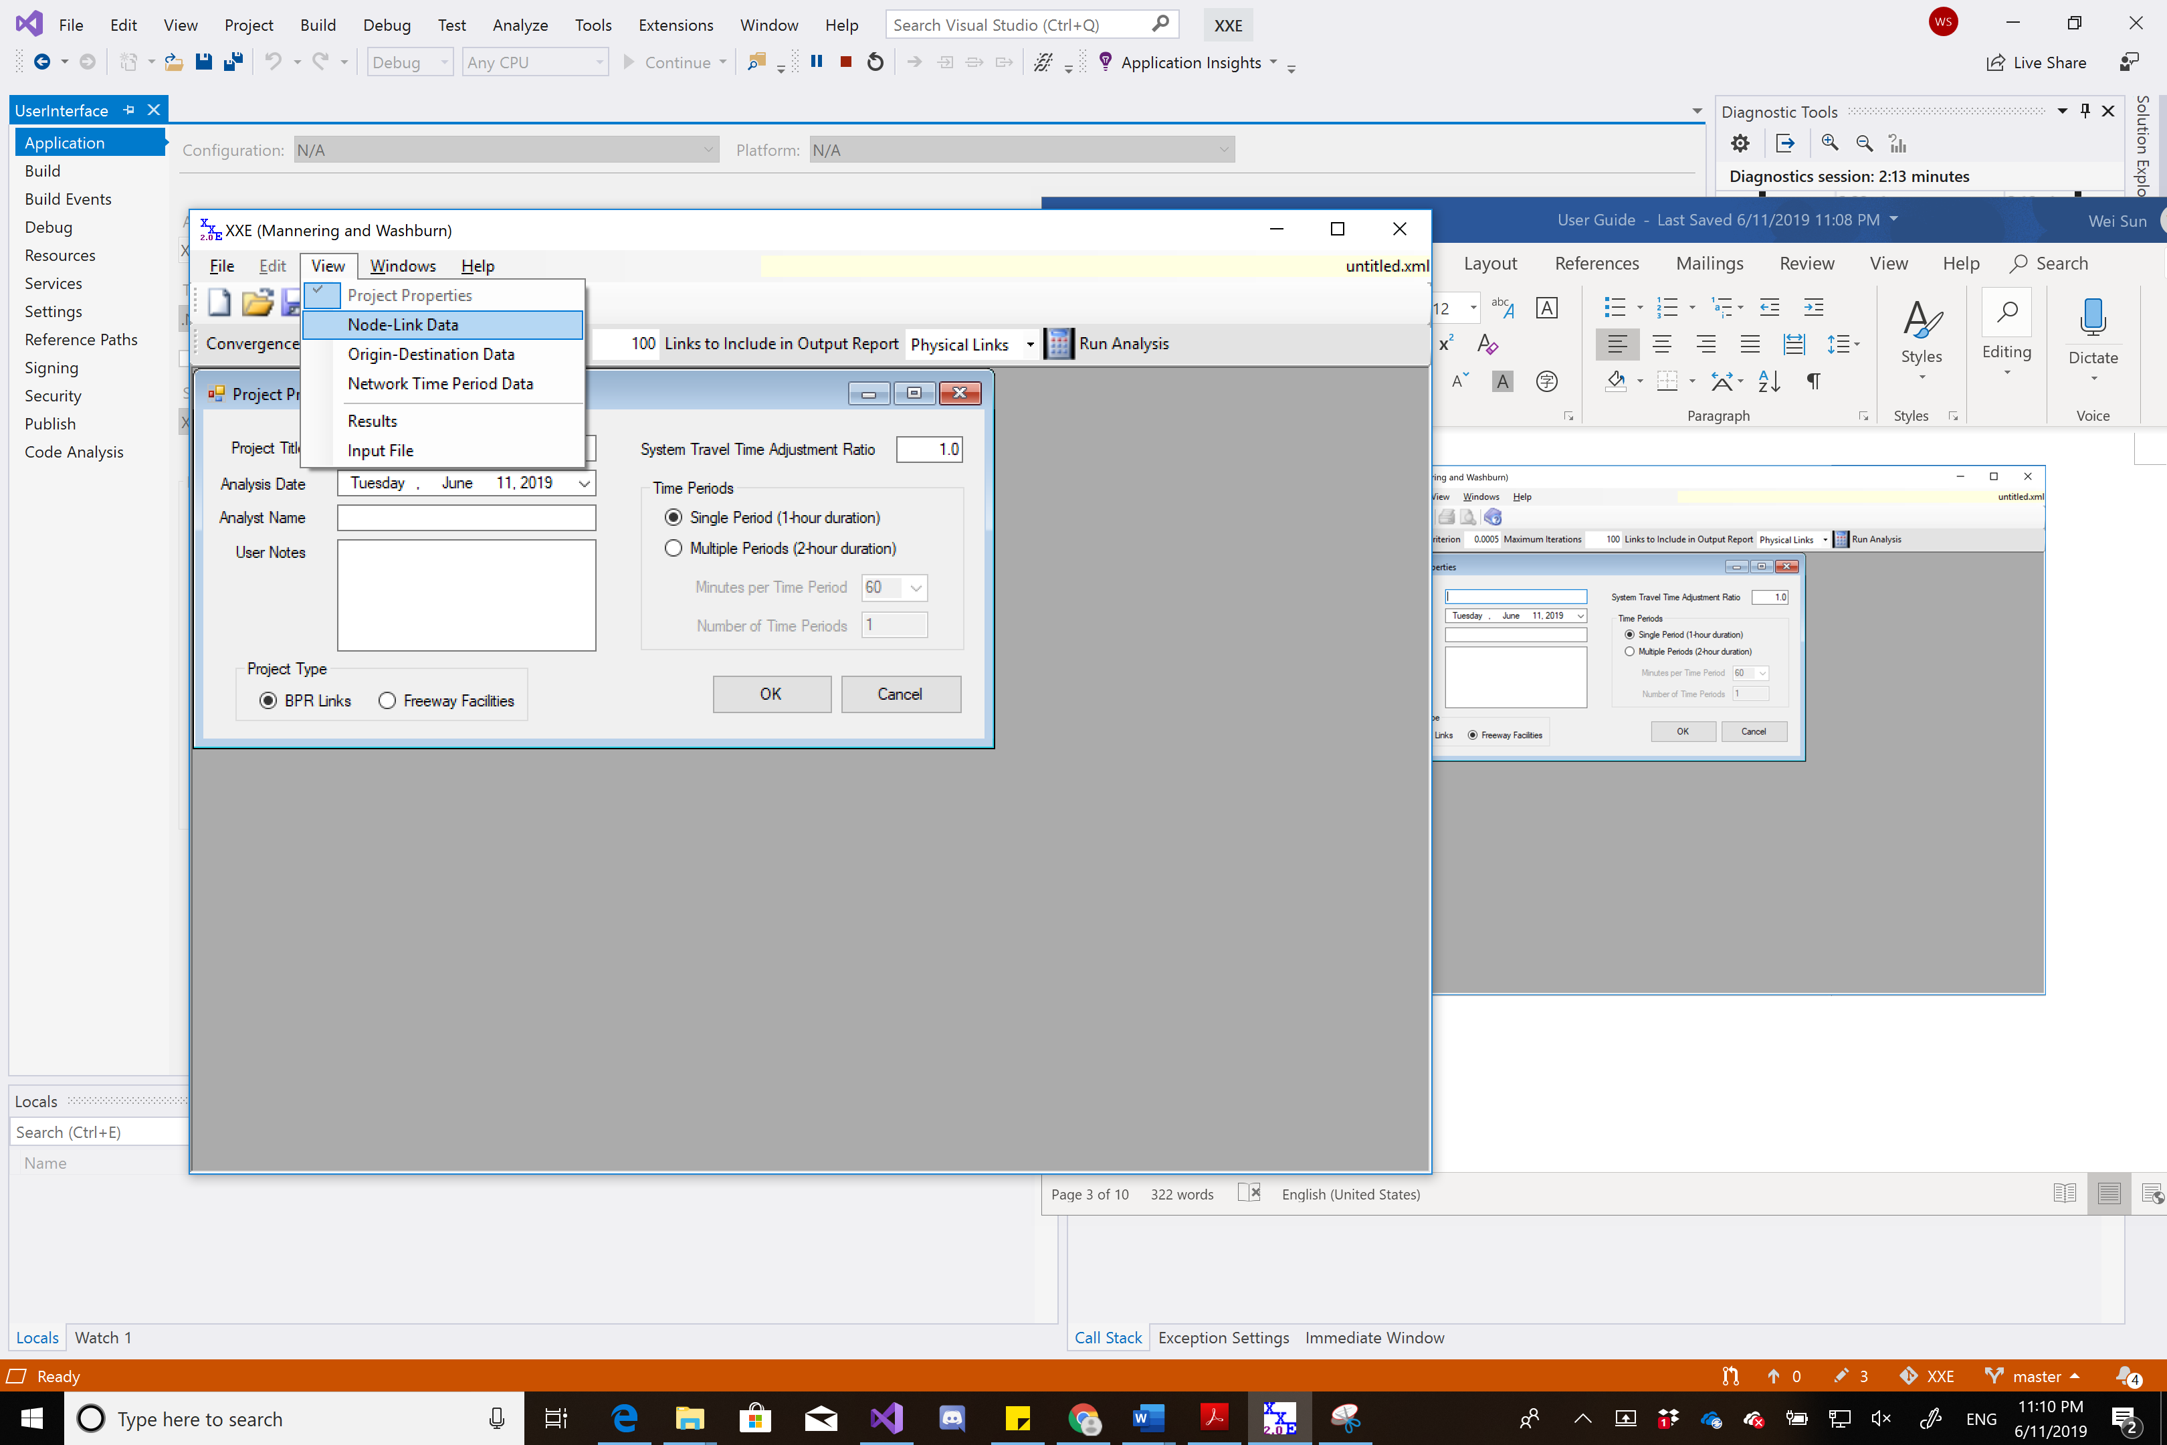

In ‘View’, select ‘Node-Link Data’.

## Specify Node-Link Data

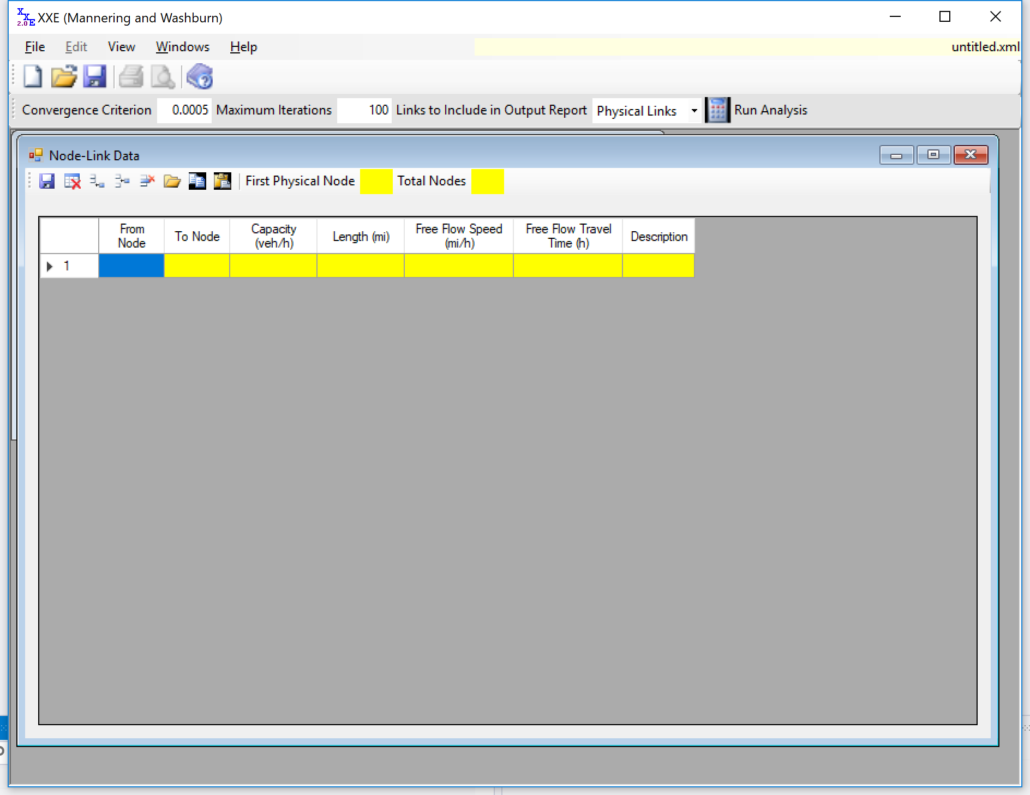

Add and specify each link information: origin node, destination node, the length (mi) of the link, the capacity (veh/h), the free-flow speed (mi/h), and the free-flow travel time (h).

## Example Horseshoe Network

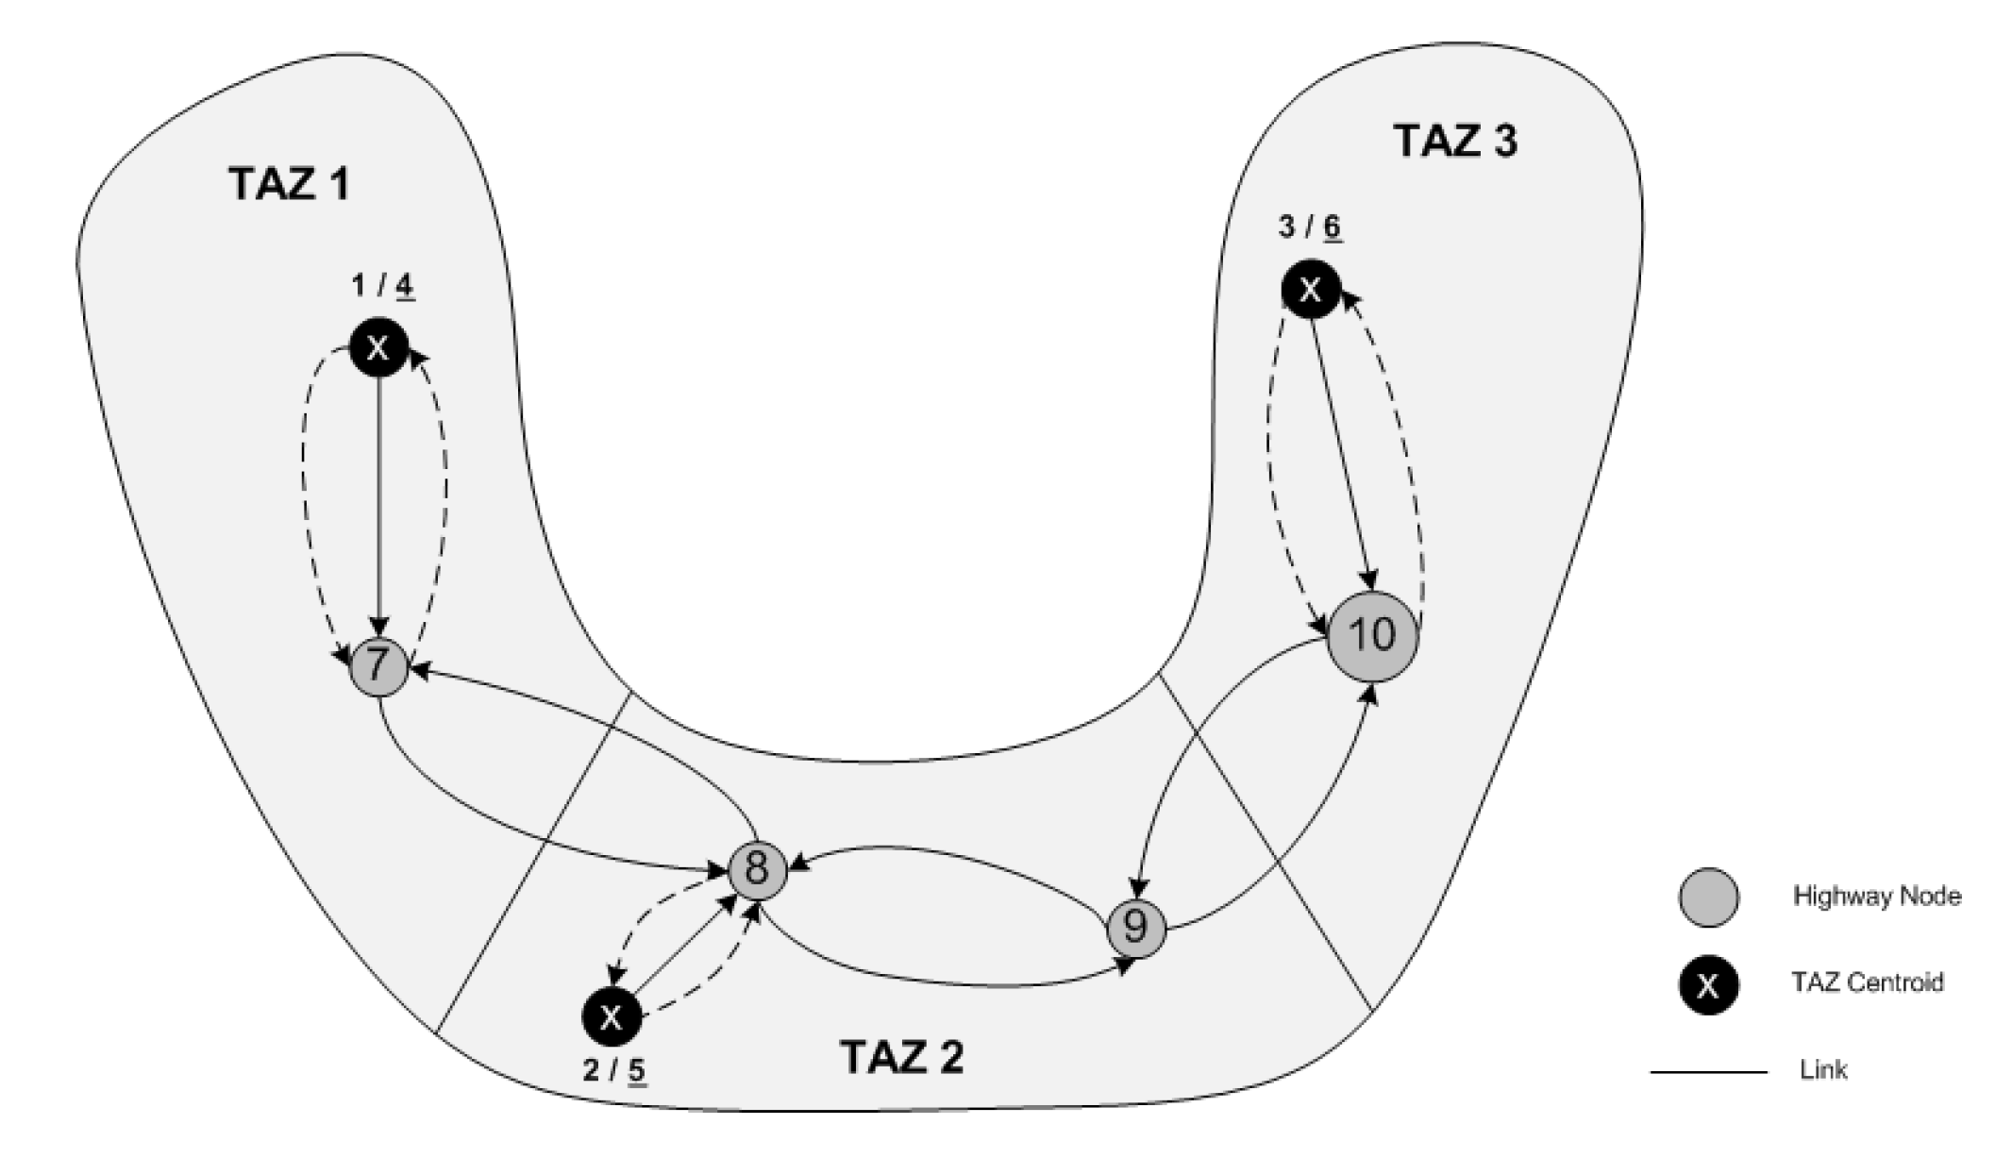

## Node Numbering

It is essential that the nodes be numbered sequentially in the following order: 1. Origin nodes. 2. Destination nodes. 3. Network nodes.

Consider the “horseshoe” network shown above, which consists of 3 traffic analysis zones (TAZs) and 6 physical links. For XXE to run a user equilibrium assignment on this network, the network must be coded as shown on the above figure and in the left table. Note that each TAZ has both an origin and destination node (as opposed to a single node). This numbering convention is needed for XXE. Thus, the number of the first network node will always be two times the number of TAZs plus 1. For the horseshoe network, this is 7 (2 × 3 + 1). Also, an additional (access/dummy) link is added from the destination node back to the physical network. A very low capacity is given to these additional links (such as 1 veh/h) and thus these links should have zero flow but they are needed in XXE.

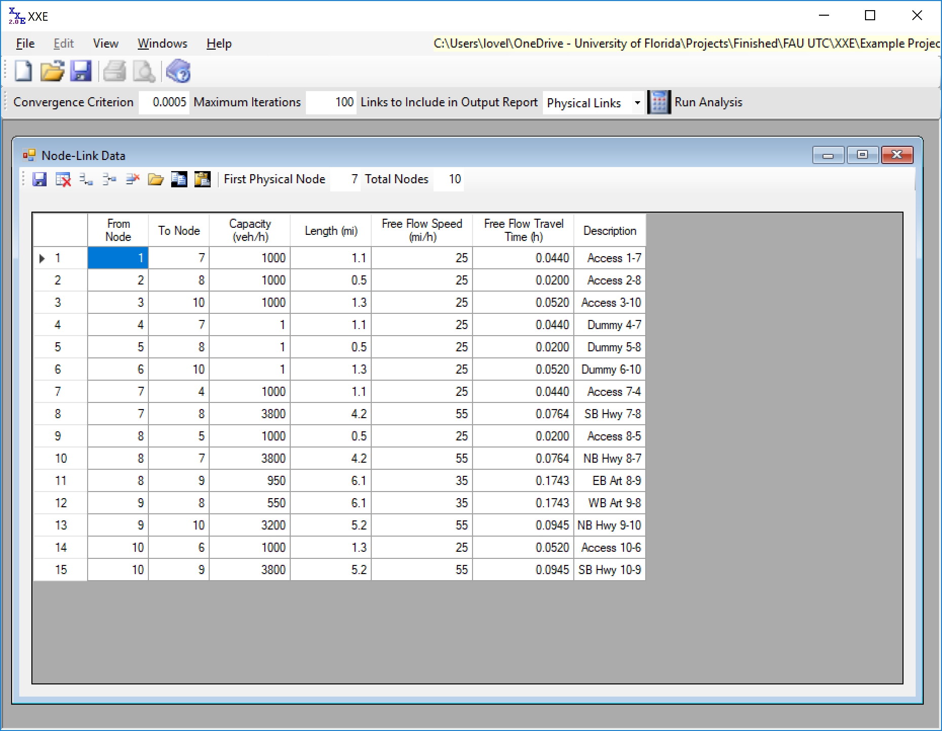

## Origin-Destination Data

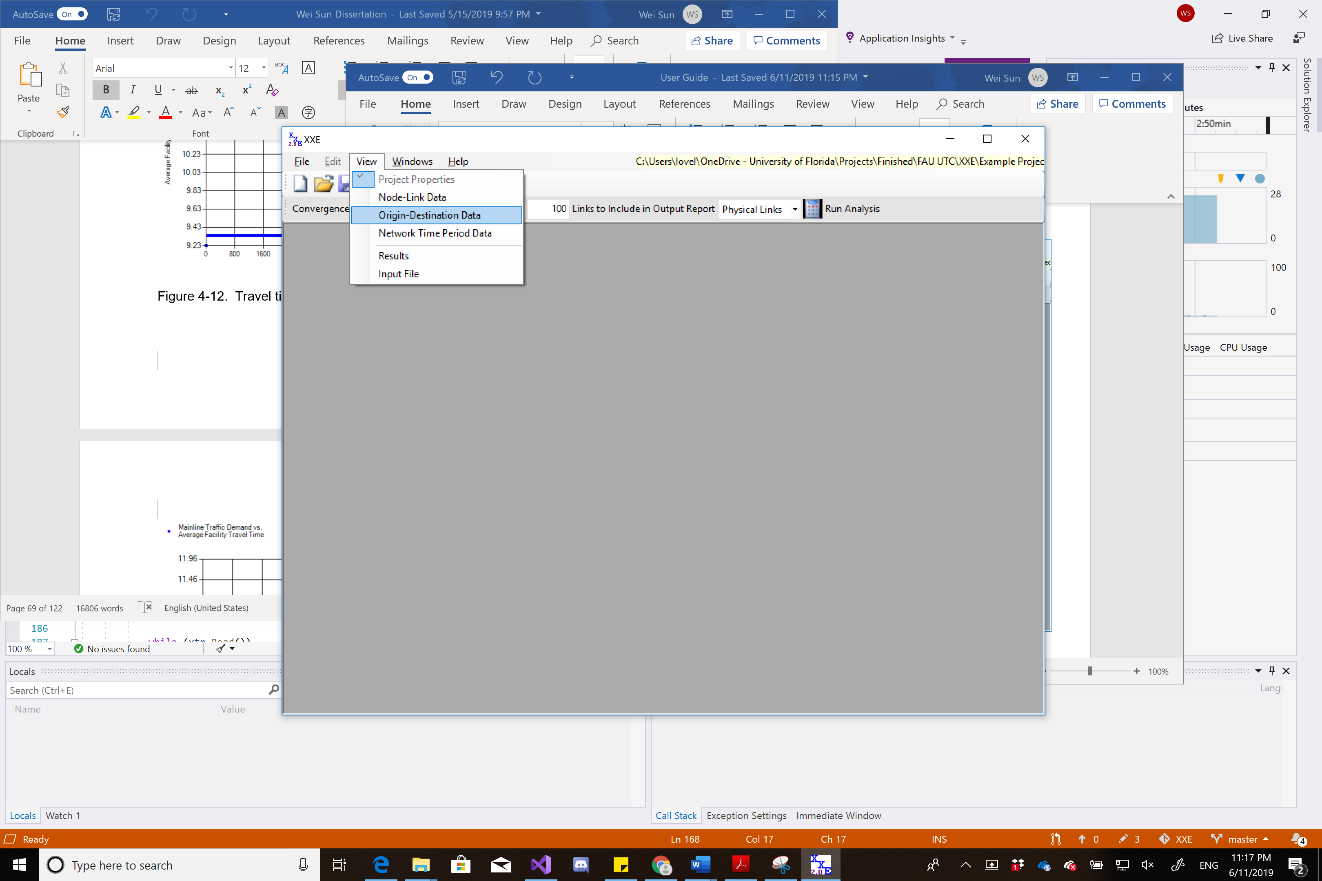

In ‘View’, select ‘Origin-Destination Data’.

## Specify Origin-Destination Data

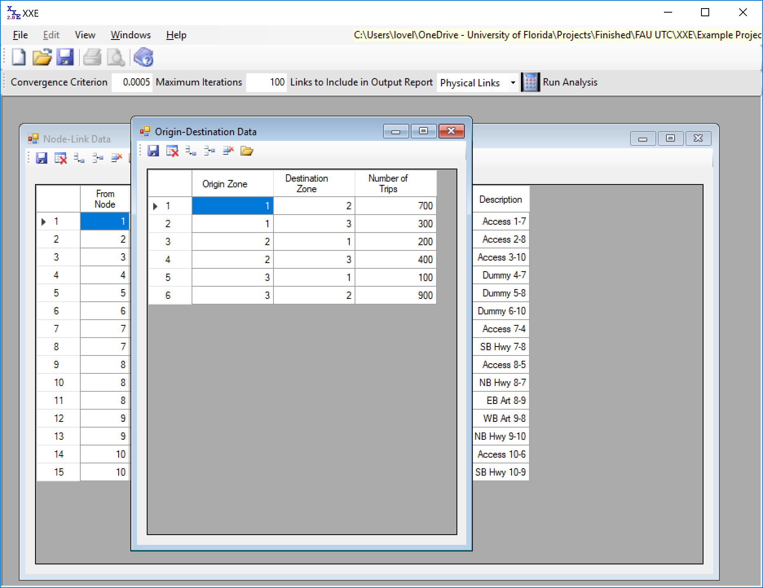

Add and specify origin-destination trips data.

## Run Analysis

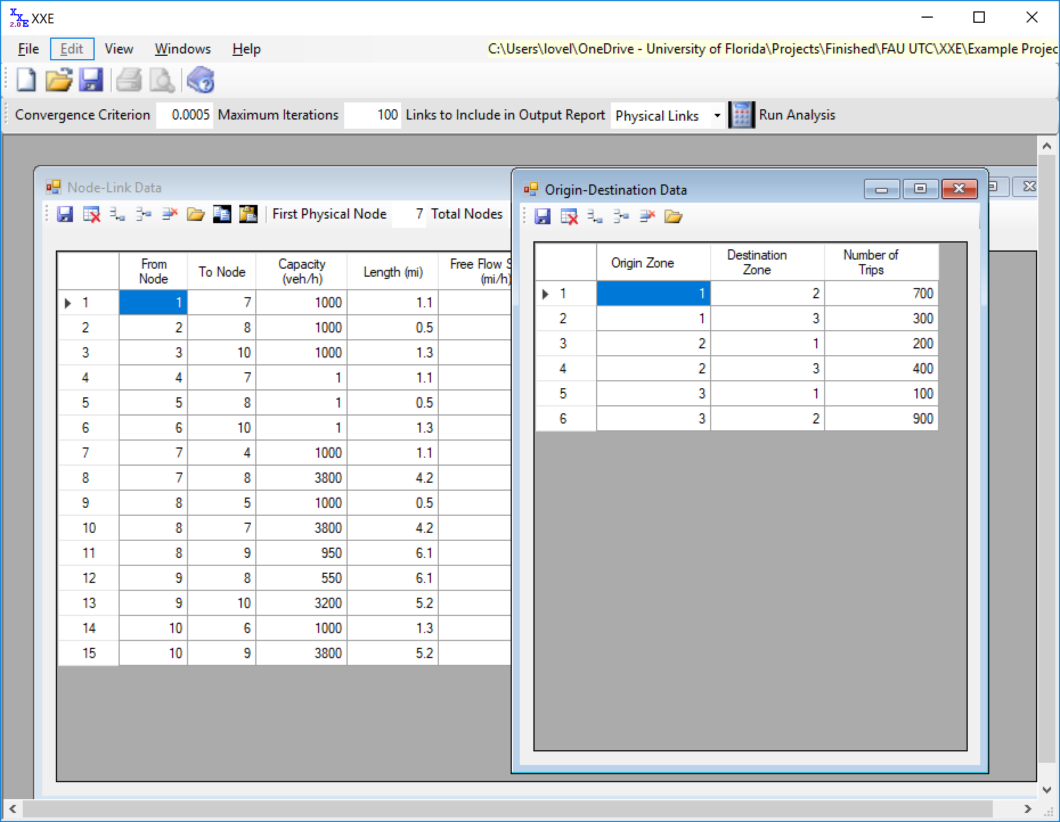

Specify convergence settings and click ‘Run Analysis’.

## Results

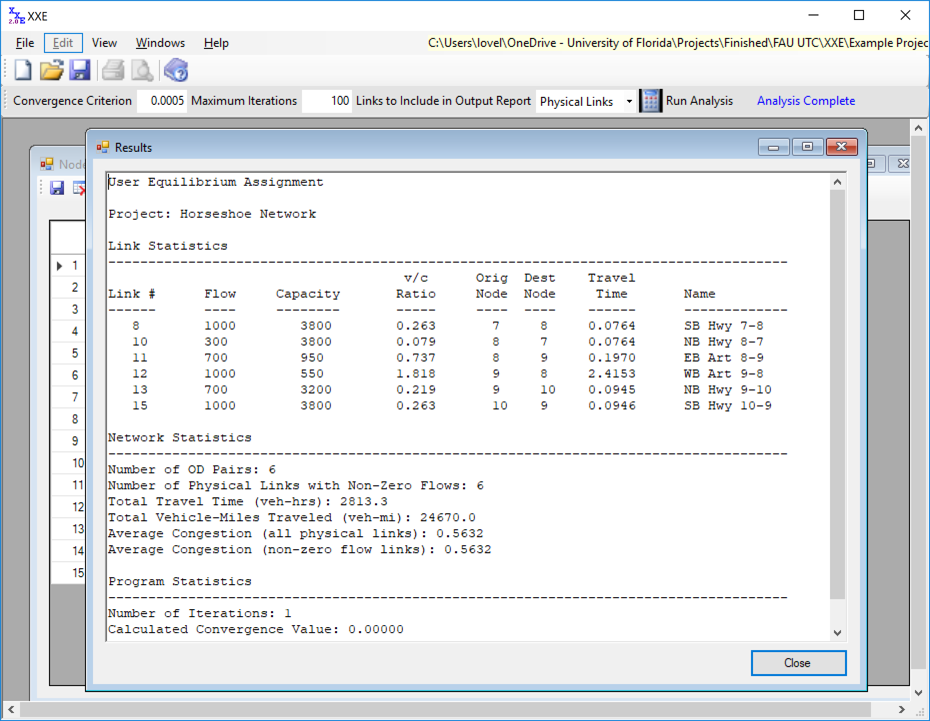

# Project (Freeway Facilities)

## Node-Link Data

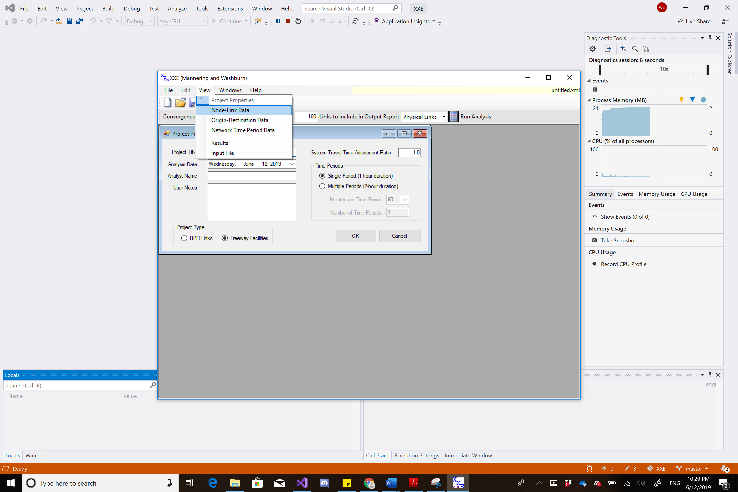

In ‘View’, select ‘Node-Link Data’.

## Specify Node-Link Data

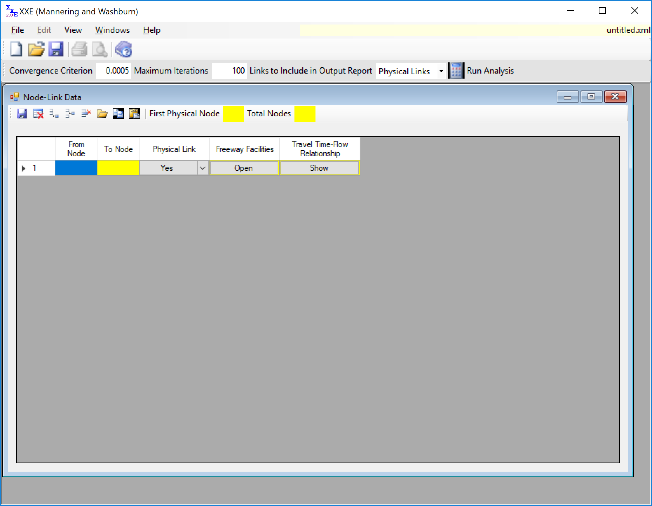

Add and specify each link information: origin node, destination node, physical link, and freeway facilities setup.

## Example Network

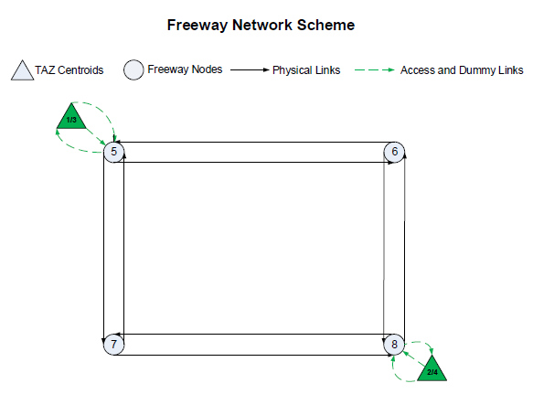

In XXE, the traffic analysis zones of the freeway network are represented by TAZ centroids (the triangles) and are consecutively numbered as origins 1 and 2. Besides serving as origins, each TAZ centroid also serves as a destination consecutively numbered 3 through 4, as shown above. After the numbering of TAZ centroids, the freeway nodes are numbered, and in this case, the freeway nodes of the example network are consecutively numbered from 5 to 8. Then, access and dummy links are added between the TAZ centroids and the connecting freeway nodes. The access and dummy links are not included in the analysis results, but are essential for the XXE network topology. The freeway facility links that are involved in the analysis results are called physical links in XXE. The above figure shows the final numbering of the nodes and the links in XXE for the example freeway network.

## Node-Link Data

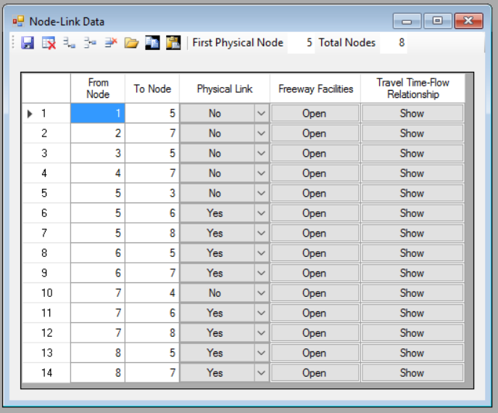

## Freeway Facilities

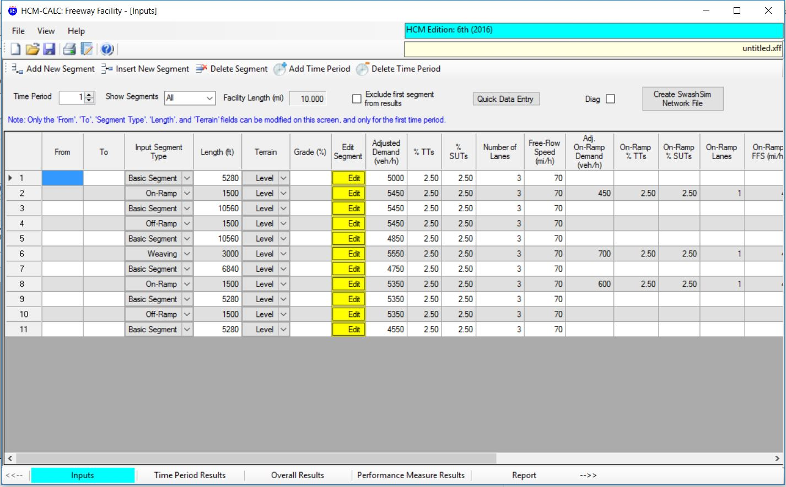

For each physical link, specify the Freeway Facilities information.

## Travel Time-Flow Relationship

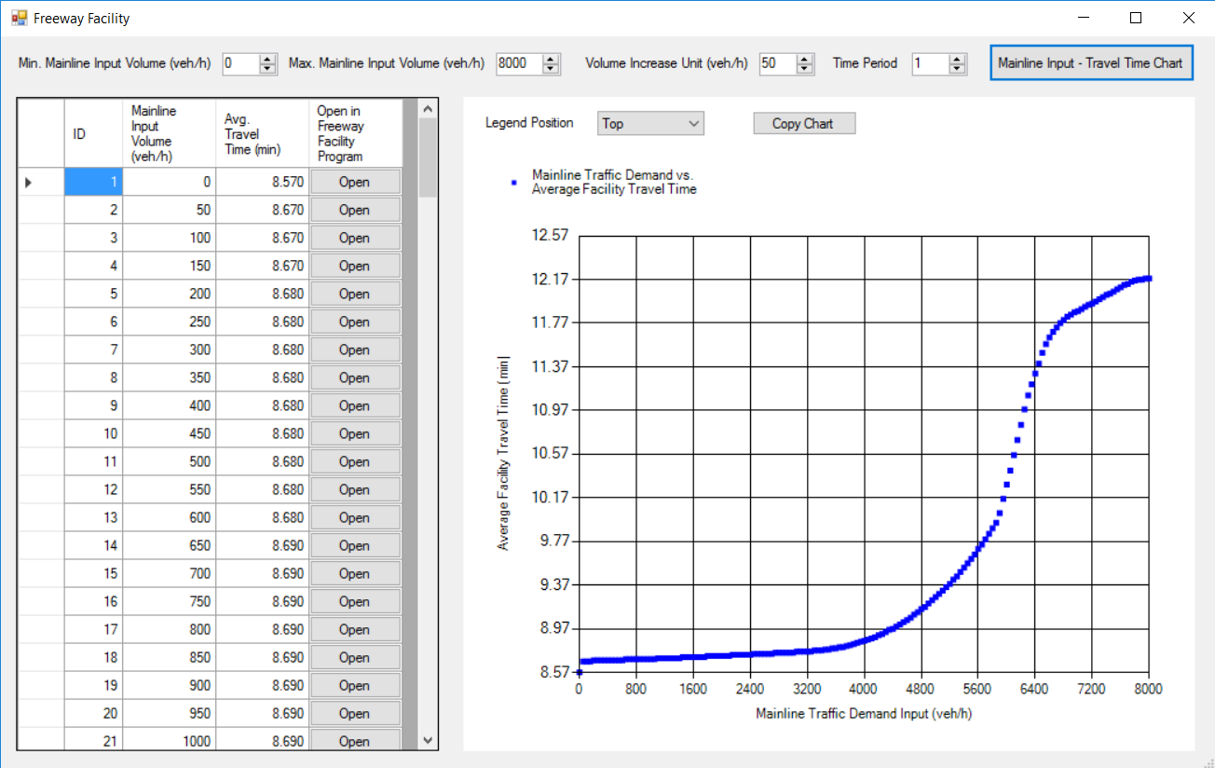

After specifying the freeway facilities information, uses can check the travel time - flow relationship of the link.

## Origin-Destination Data

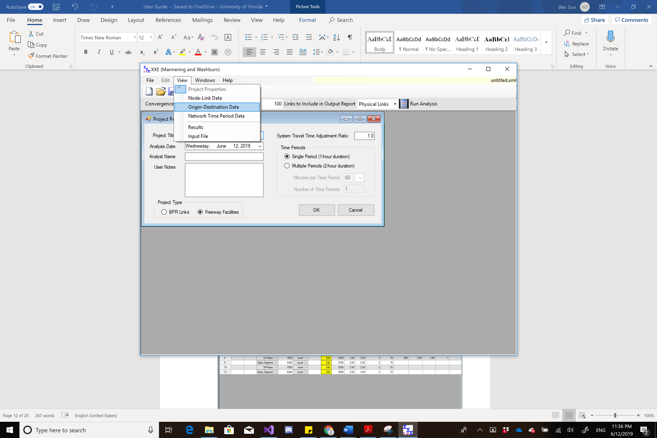

In ‘View’, select ‘Origin-Destination Data’.

## Specify Origin-Destination Data

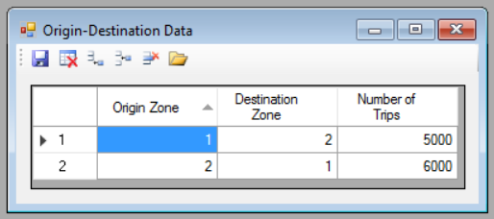

## Run Analysis

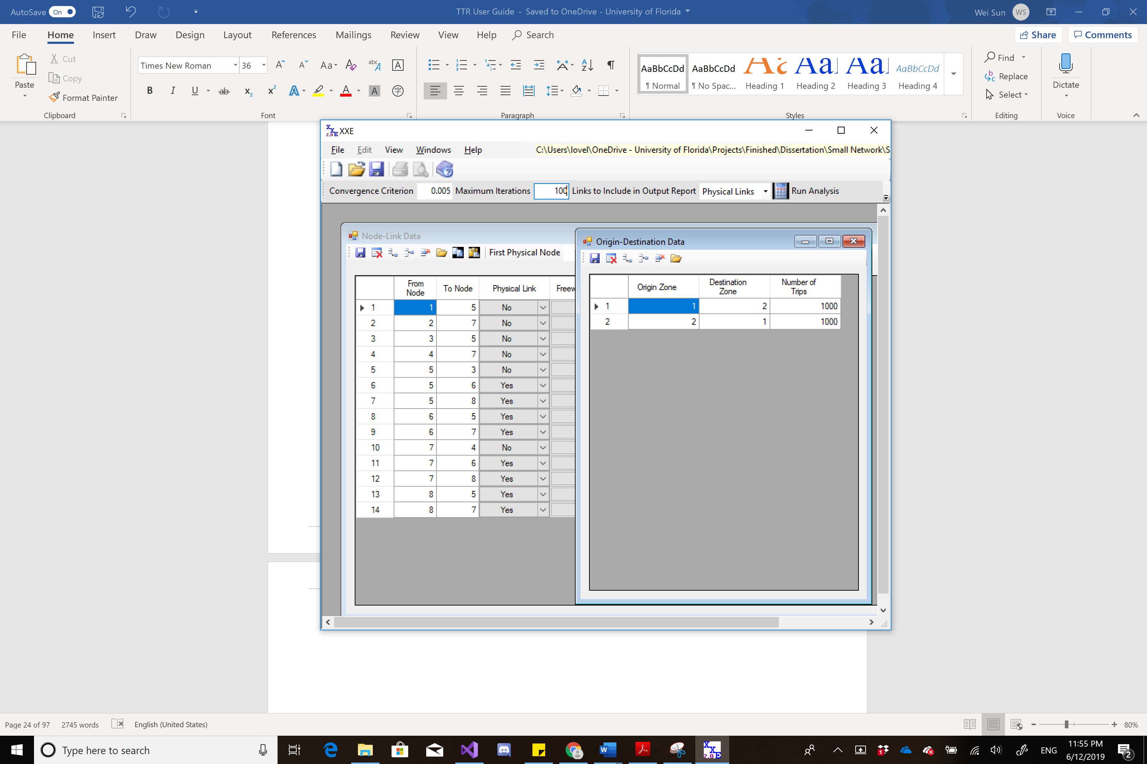

Specify convergence settings and click ‘Run Analysis’.

## Results

